**COMSATS University**

**Islamabad**



**Semester Project Report**

**Real Time Embedded Systems**

**(EEE-446)**

|  |
| --- |
| IOT Based Home Automation System using ESP-32. |

**Submitted By:**

**Arwa Aamir (FA16-EEE-002)**

**Submitted To:**

**Dr. Ahsen Malik**

Table of Contents

IOT Based Home Automation System using ESP-32. 1

Abstract 3

Introduction 4

Project Background and Description 4

Need of Home Automation Systems 4

Working and Deliverables 4

Advantages / Scope / Applications 5

Methodology 6

System Design: 6

System Dataflow: 6

Block diagram: 7

Software Description 8

Arduino IDE Code: 8

Andoid Application via MIT App Inventer 11

Android Application: 11

Database via Google Firebase 12

Database Implementation: 12

Hardware Description 13

Implementation: 13

Conclusion 15

# Abstract

The latest advancement in the home automation industry is the introduction of Voice User Interface (VUIs). Different companies such as Apple, Amazon and Google have introduced their own Personas such as Siri, Alexa, and Google Assistant. The primary advantage of a VUI is that it allows for a hands-free, eyes-free way in which users can interact with a product while focusing their attention elsewhere. This purpose can also be served using mobile apps that upload data on a database and the microcontroller reads it and controls the actuators.

This project makes use of database-controlled apps and controls the home appliances via Wi-Fi and using a mobile app. It also involves automatic water motor control and user-controlled speed of fan.

# Introduction

Home Automation is a wireless home appliance control system accessed by a remote device such as mobile phone(Android or IOs) to allow a homeowner to control, monitor and coordinate home appliances, without changing the home infrastructure.

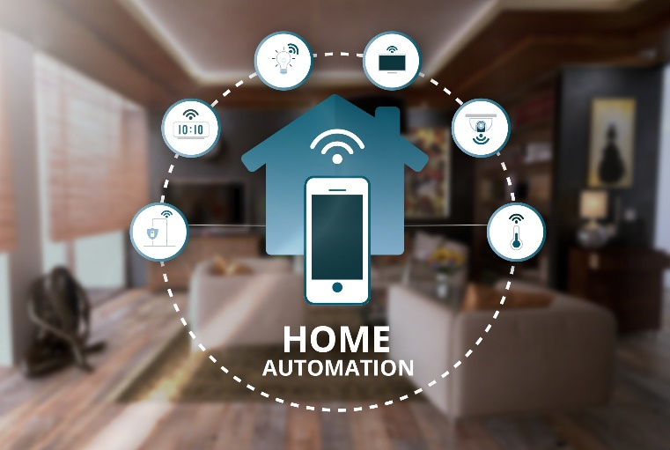

## Project Background and Description

With the ever-growing advancements in technology, everything in our surroundings is being automated to reduce time and increase efficiency. The Internet of Things is growing day by day and gradually affecting every business and even the lifestyles of humans. In this day and time, it is essential for us as the members of this advanced and progressing society to improve our standards of life, and have efficient systems surrounding us that make life easy so we can focus out energy further improvements. Home Automation Systems have prevailed largely in the market in the last decade and are improving day by day. They play a significant part in reducing the man labor and making the human life easy and effortless.

## Need of Home Automation Systems

They are primarily needed for the following advantages:

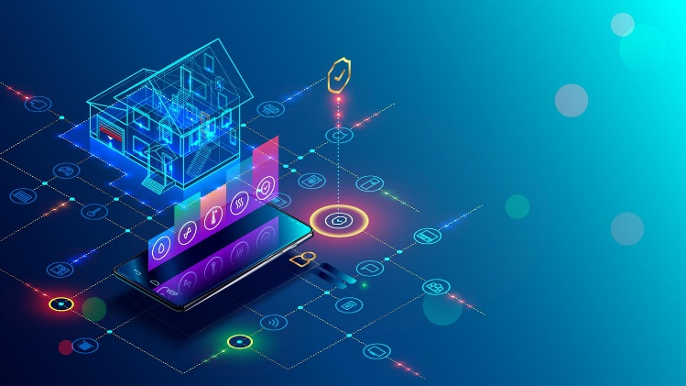1. Saves time

2. Save money (Long run)

3. Self-Maintenance

4. Security

5. Makes life easy

## Working and Deliverables

The deliverables will be in the form of an extension which will have 4 AC ports in which any AC appliances can be plugged, 2 of the ports(AC Lights) will have a simple on/off user defined input while the 3rd port (fan) will also have the variable user defined speed function. The 4th port will be for the water motor, it will monitor the water level and turn on and off automatically.

## Advantages / Scope / Applications

Along with serving the advantages of smart home, I aim to make my project portable in the form of an automated extension which can not only be used at home but also in office or any other place easily. This will give user the ease of access not only at home but also other places as well. This product form is very beneficial as we only need and AC source at a place on which the extension has to be plugged and we can extend the benefits of IOT to wherever we go without any additional wiring or circuitry

# Methodology

## System Design:

* HA is a system which is controlled by a remote system such as a cell phone like , Android or IOs Phone.
* It is built around a microcontroller, with adjoining relays for interfacing with AC devices.
* There will be sensors for the system to operate automatically according to weather conditions.
* In case of emergency such as fire, the user or an organization such as Fire Department should be notified.
* Also, HA should have a database of information about the users and appliances.

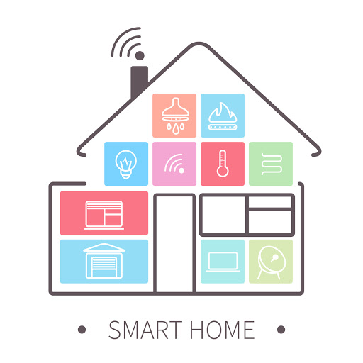

## System Dataflow:

Shows How Data flows between different levels in an Home Automation System.

## Block diagram:

Shows the major blocks of the HA System.

220V AC

7805 Voltage regulator

AC-Dc Adapters 220VAC-12VAC (2A)

# Software Description



## Arduino IDE Code:

|  |
| --- |
| #include <WiFi.h> // esp32 library  #include <IOXhop_FirebaseESP32.h> // firebase library  #define FIREBASE_HOST "home-auto-68ecd.firebaseio.com" //Your Firebase //Project URL goes here without "http:" , "\" and "/"  #define FIREBASE_AUTH "Nd9I75WwCuUWeCXvKCkwdZKNVfa4lxpgqm7RqvfC"  //Your Firebase Database Secret goes here  #define WIFI_SSID "PinkPanther" //your WiFi SSID for which yout NodeMCU connects  #define WIFI_PASSWORD "AFA123E185" //Password of your wifi network  String fireStatus1 = ""; // led status received from firebase  String fireStatus2 = "";  String fireStatus3 = "";  String fireStatus4 = "";  String fireStatus5 = "";  int fanspeed;  const int water_sensor = 2; //D4  int k;  void setup() {  Serial.begin(9600);  pinMode(water_sensor, INPUT); // Sets the echoPin as an Input    pinMode(12, OUTPUT);  pinMode(13, OUTPUT);  pinMode(14, OUTPUT);  pinMode(15, OUTPUT);  digitalWrite(12, HIGH);  digitalWrite(13, HIGH);  digitalWrite(14, HIGH);  digitalWrite(15, HIGH);    WiFi.begin(WIFI_SSID, WIFI_PASSWORD); //try to connect with wifi  Serial.print("Connecting to ");  Serial.print(WIFI_SSID);  while (WiFi.status() != WL_CONNECTED) { Serial.print(".");  delay(500);  }  Serial.println();  Serial.print("Connected to ");  Serial.println(WIFI_SSID);  Serial.print("IP Address is : ");  Serial.println(WiFi.localIP()); //print local IP address  Firebase.begin(FIREBASE_HOST, FIREBASE_AUTH); // connect to firebase  Firebase.setString("LED1", "0"); //send initial string of led status  Firebase.setString("LED2", "0");  Firebase.setString("LED3", "0"); //send initial string of led status  Firebase.setString("LED4", "0");  }  void loop() {    k=digitalRead(water_sensor);  fireStatus4 = Firebase.getString("LED4");  if (fireStatus4 == "1") { // compare the input of led status received from firebase  if(k==LOW)  {  digitalWrite(15, LOW); // make output led ON  Serial.println("Led4 Turned ON");  }  else  {  digitalWrite(15,HIGH); // make output led OFF  Serial.println("Led4 Turned OFF");  }  }  else if (fireStatus4 == "0") { // compare the input of led status received from firebase  Serial.println("Led4 Turned OFF");  digitalWrite(15, HIGH); // make output led OFF  }  else {  Serial.println("Wrong Credential for LED4! Please send ON/OFF");  }  fireStatus1 = Firebase.getString("LED1"); // get led status input from firebase  fireStatus2 = Firebase.getString("LED2"); // get led status input from firebase  fireStatus3 = Firebase.getString("LED3"); // get led status input from firebase  fireStatus5 = Firebase.getString("FANSPEED");  if (fireStatus1 == "1") { // compare the input of led status received from firebase  Serial.println("Led1 Turned ON");  digitalWrite(12, LOW); // make output led ON  }  else if (fireStatus1 == "0") { // compare the input of led status received from firebase  Serial.println("Led1 Turned OFF");  digitalWrite(12, HIGH); // make output led OFF  }  else {  Serial.println("Wrong Credential for LED1! Please send ON/OFF");  }  if (fireStatus2 == "1") { // compare the input of led status received from firebase  Serial.println("Led2 Turned ON");  digitalWrite(13, LOW); // make output led ON  }  else if (fireStatus2 == "0") { // compare the input of led status received from firebase  Serial.println("Led2 Turned OFF");  digitalWrite(13, HIGH); // make output led OFF  }  else {  Serial.println("Wrong Credential for LED2! Please send ON/OFF");  }  if (fireStatus3 == "1") { // compare the input of led status received from firebase  Serial.println("Led3 Turned ON");  digitalWrite(14, LOW); // make output led ON  }  else if (fireStatus3 == "0") { // compare the input of led status received from firebase  Serial.println("Led3 Turned OFF");  Serial.println("FAN SPEED IS:");  fanspeed=fireStatus5.toInt();  Serial.println(fanspeed);  digitalWrite(14, HIGH); // make output led OFF  }  else {  Serial.println("Wrong Credential for LED3! Please send ON/OFF");  }  } |

## Andoid Application via MIT App Inventer

## Android Application:

## Database via Google Firebase

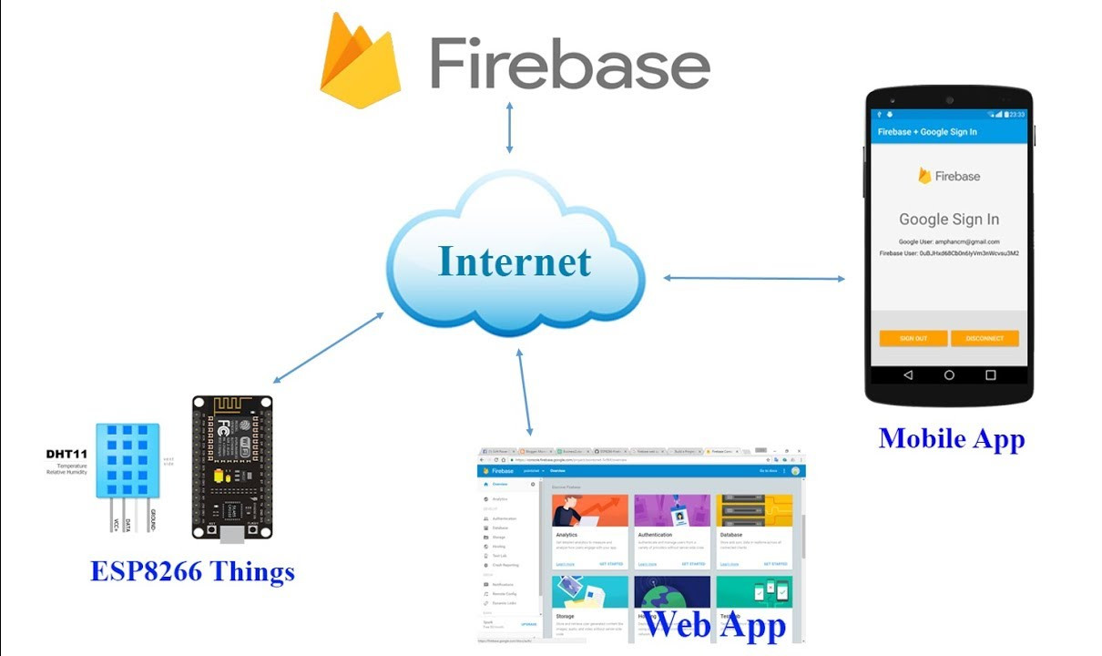

## Database Implementation:

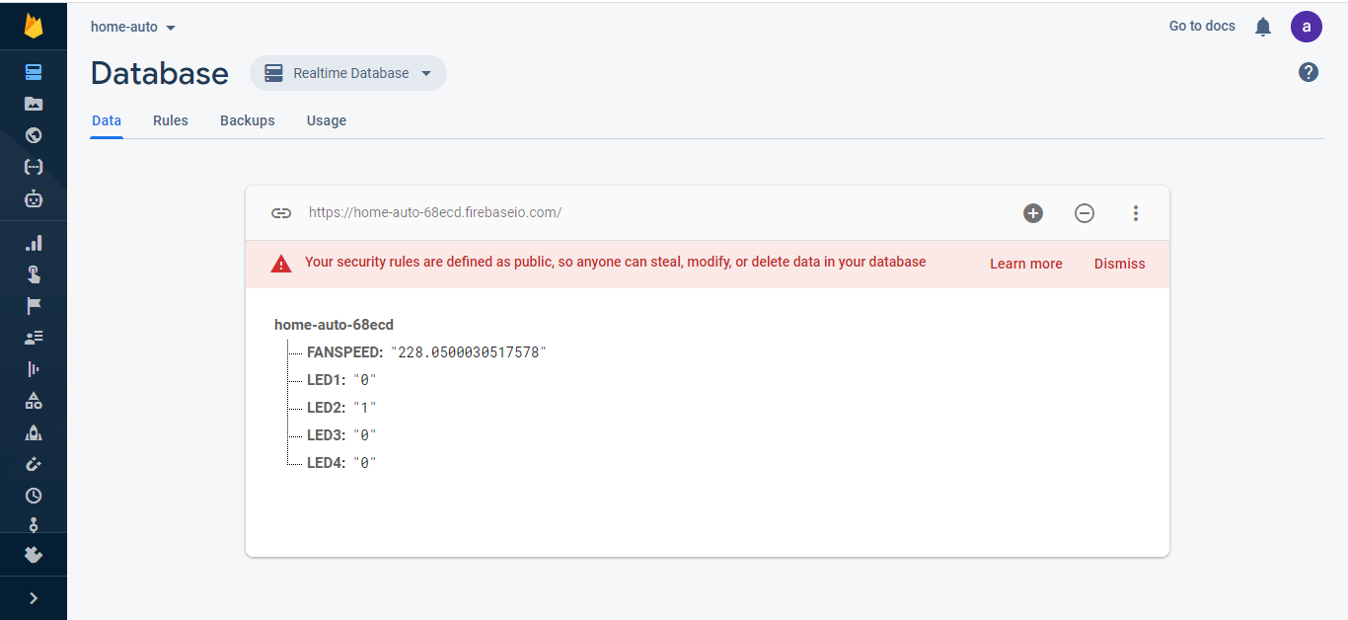

# Hardware Description

* Home automation contains a controller, various sensors, relays, motors, and further A.C. Appliances which are needed to be controlled.
* It has ESP32 controller which provides the necessary signals for then output devices connected.
* A water level sensor is used to control the automatic water motor.
* Relays are connected in the circuit to switch the AC appliances and isolate them from the microcontroller.
* AC-DC adapters are used for powering up the microcontrollers and DC Motors.
* Voltage Regulators and Buck Converters are also used to bring down the level of DC voltage and restrain it to a constant level and avoid surges.

## Implementation:

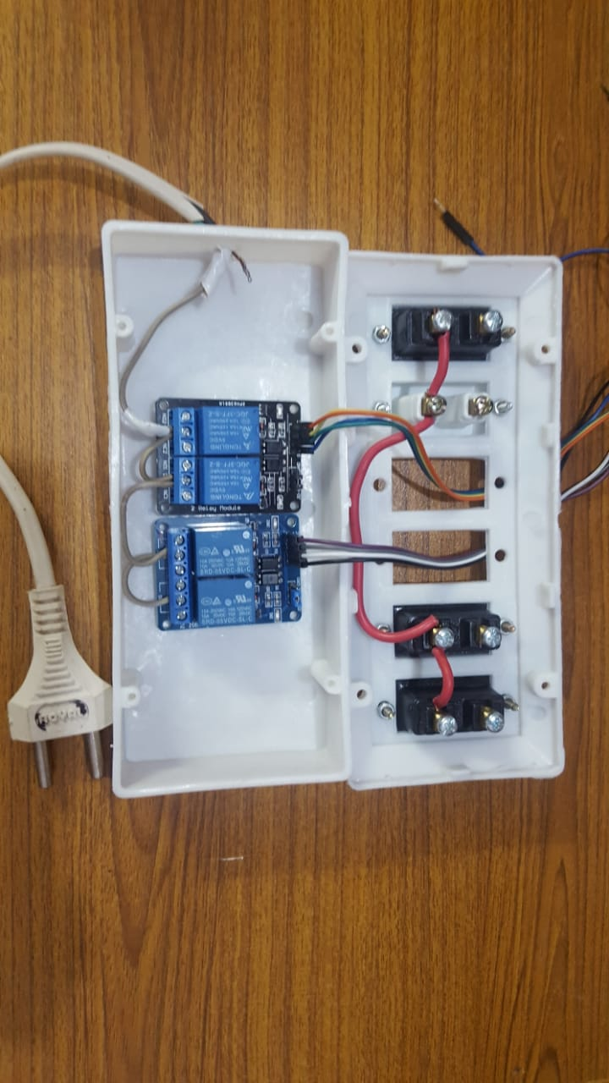

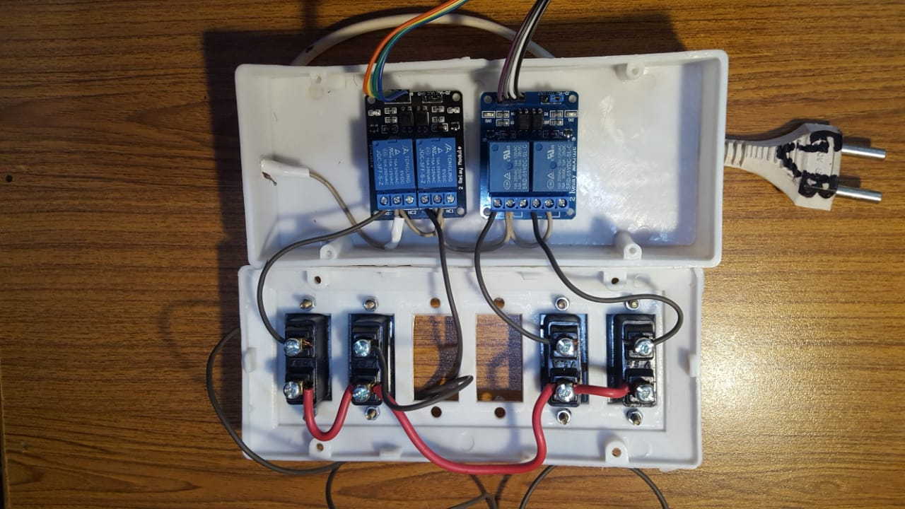

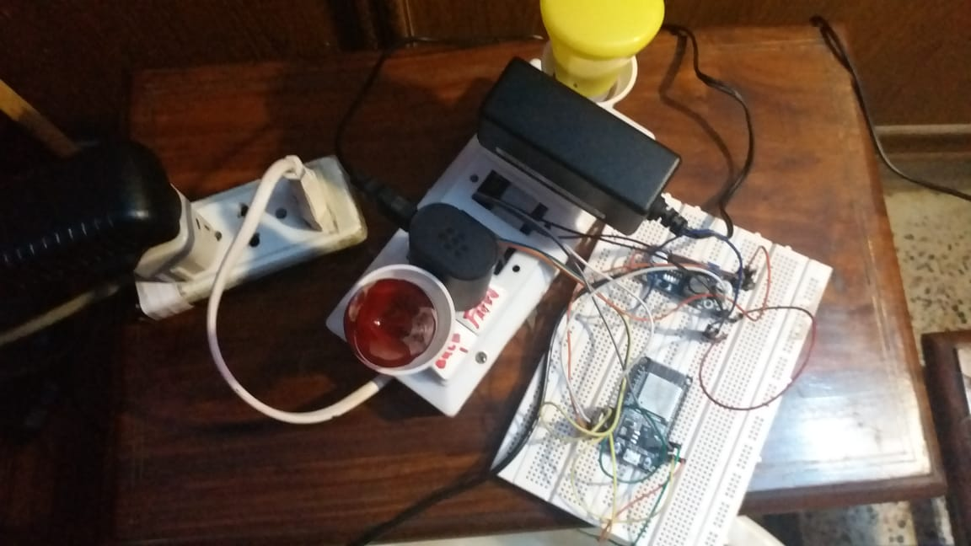

# Conclusion

A Home Automation System has been created along with a firebase on Google Firebase and Android Application using MIT App Inventor.

The App updates the data on the database and the ESP-32 reads the data from the database. The ESP-32 further sends the control signals to the relays which further controls the AC Loads. A water level sensor is also used to detect the water level and automatically turn on and off the water pump motor.